https://vk.com/wall-212007145_2312
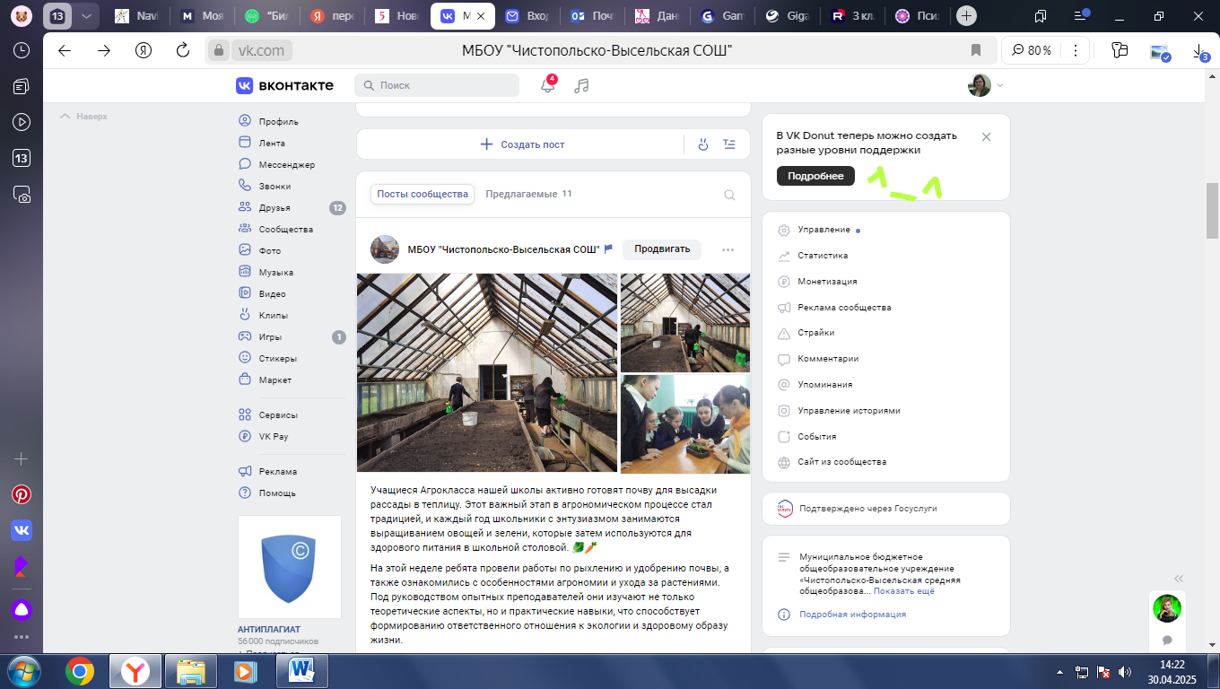
https://vk.com/wall-212007145_2309
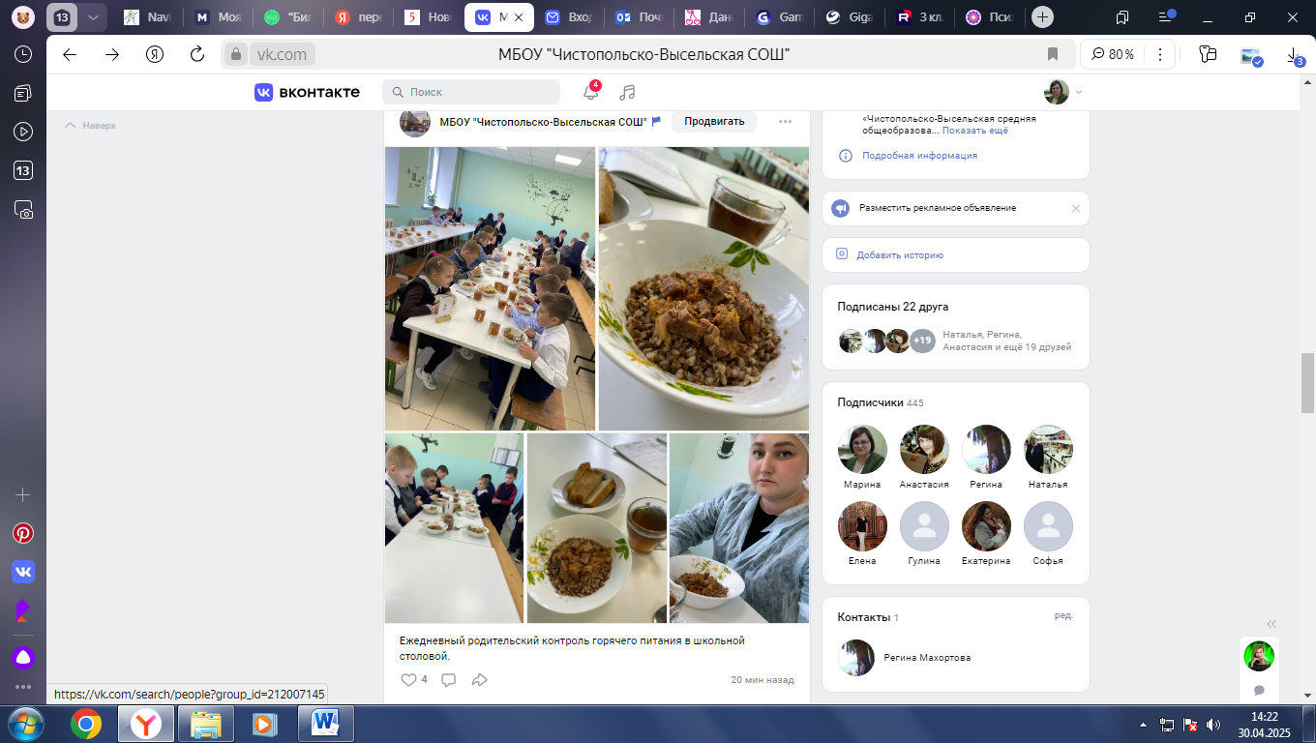

https://vk.com/wall-212007145_2265
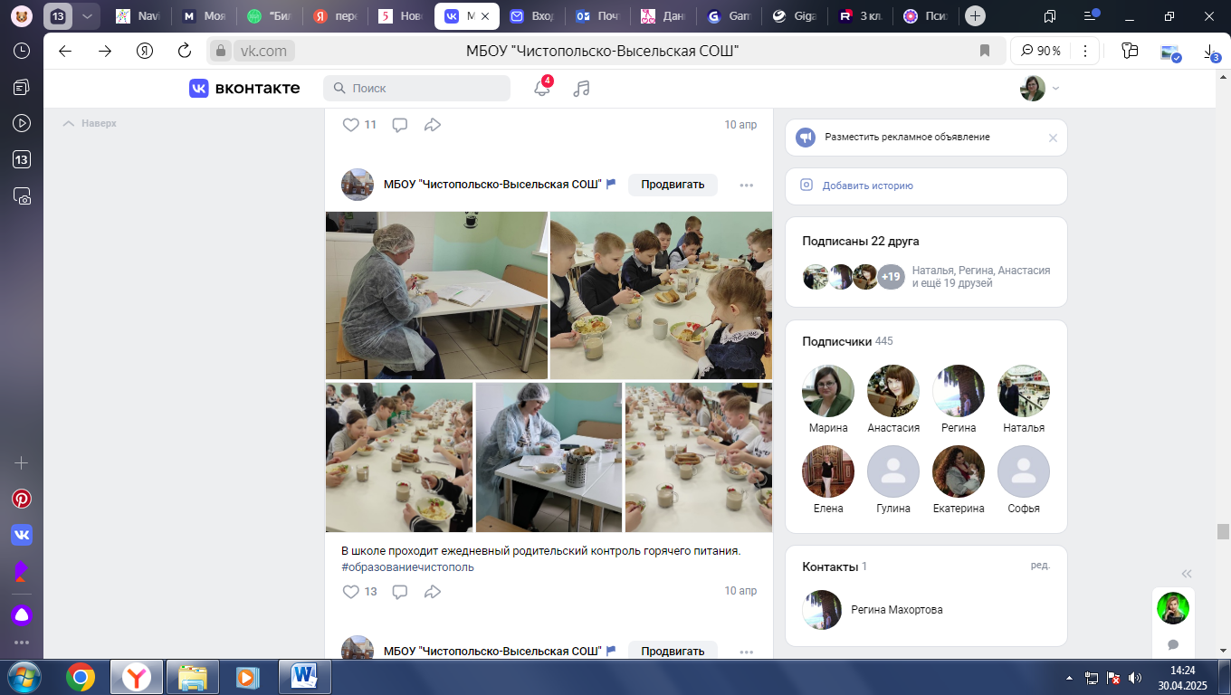
https://vk.com/wall-212007145_2261
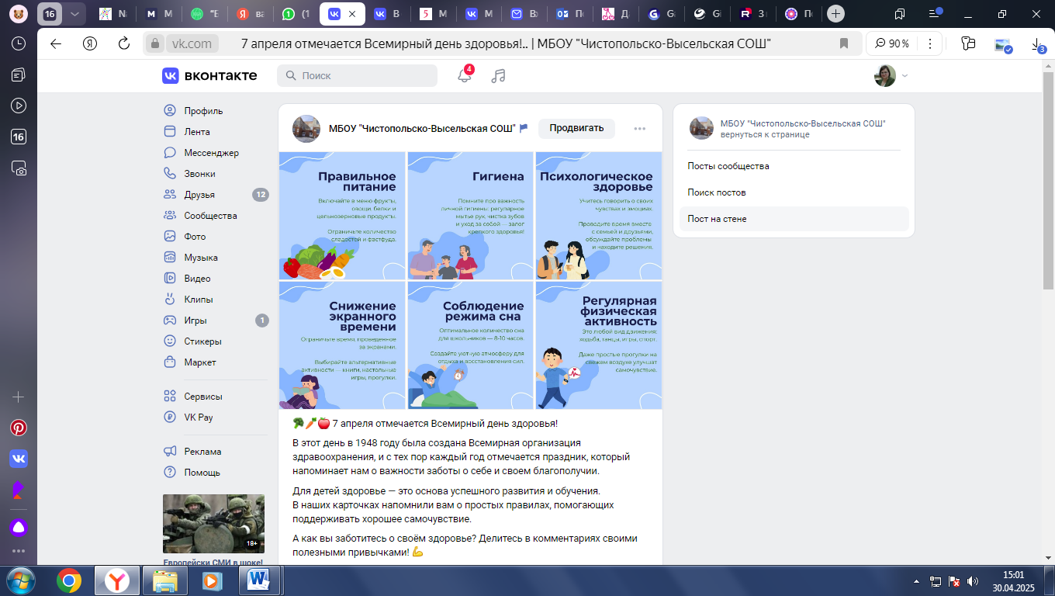

https://vk.com/wall-212007145_2221
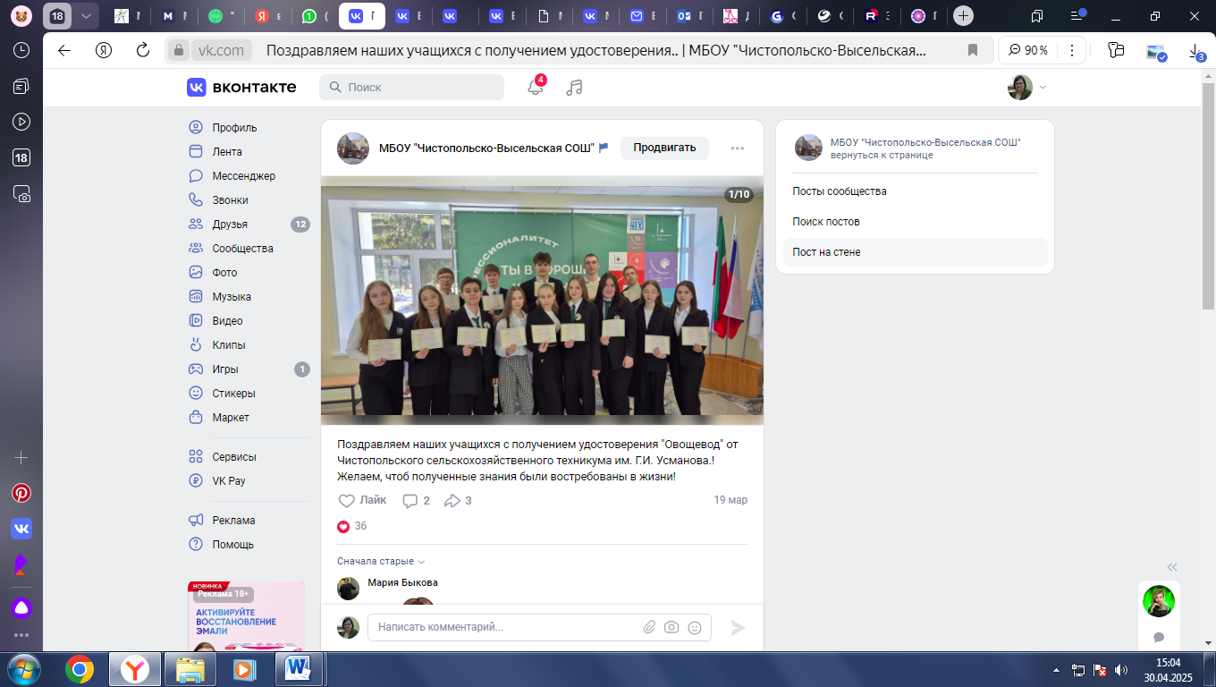
https://vk.com/wall-212007145_2203
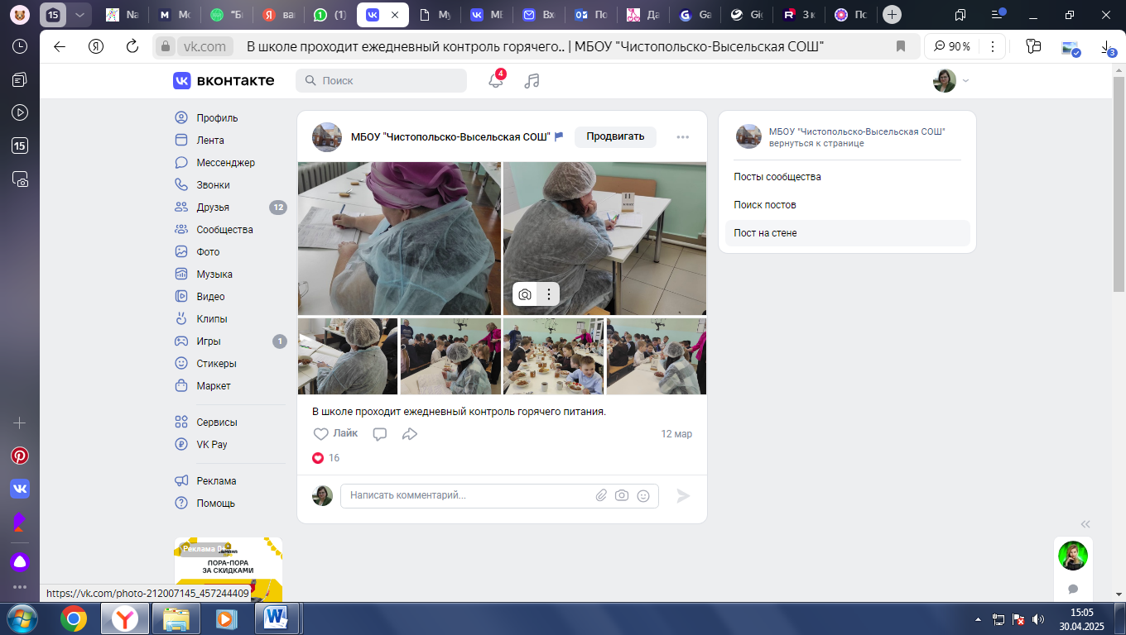

https://vk.com/wall-212007145_2163
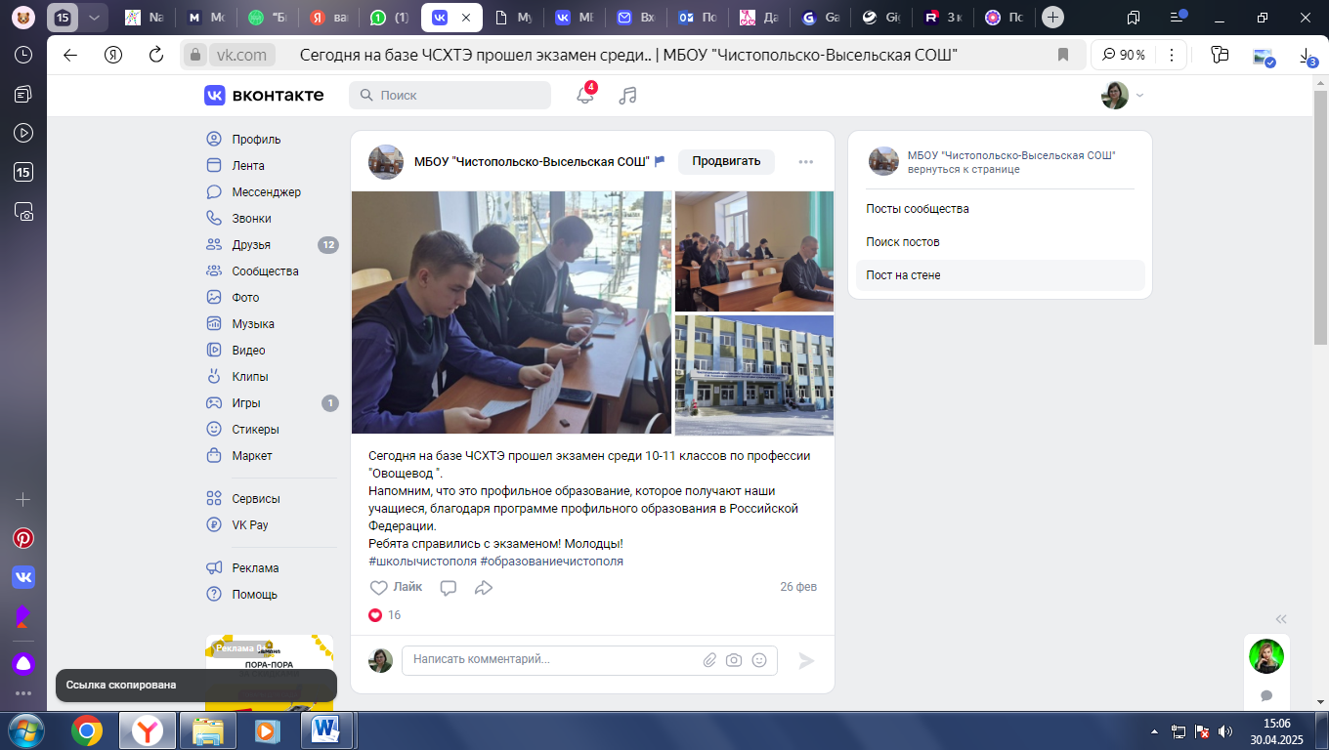
https://vk.com/wall-212007145_2157
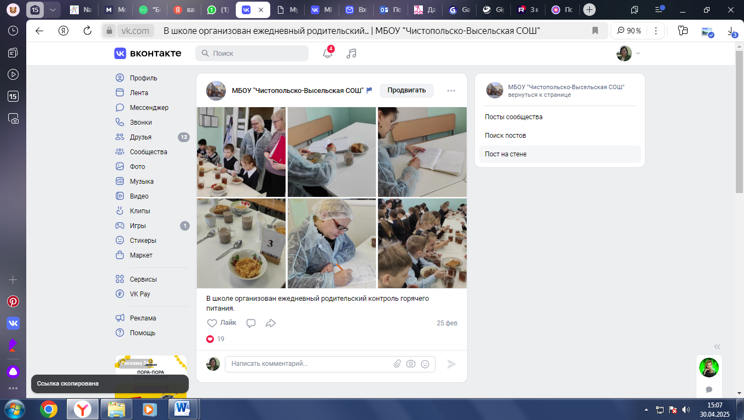

https://vk.com/wall-212007145_2092
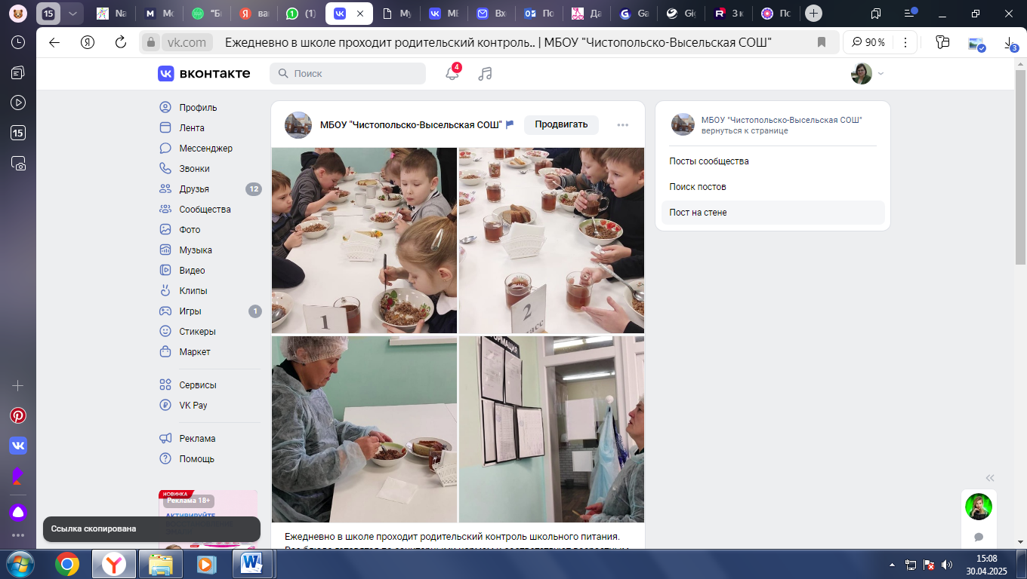
https://vk.com/wall-212007145_2073
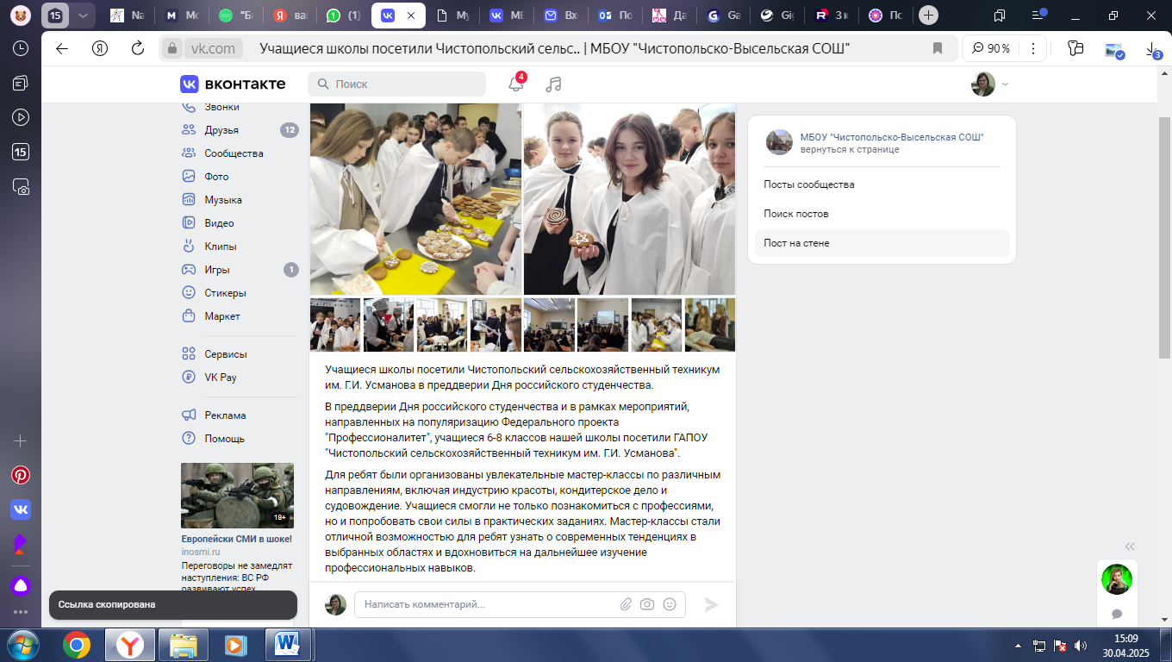

https://vk.com/wall-212007145_1970
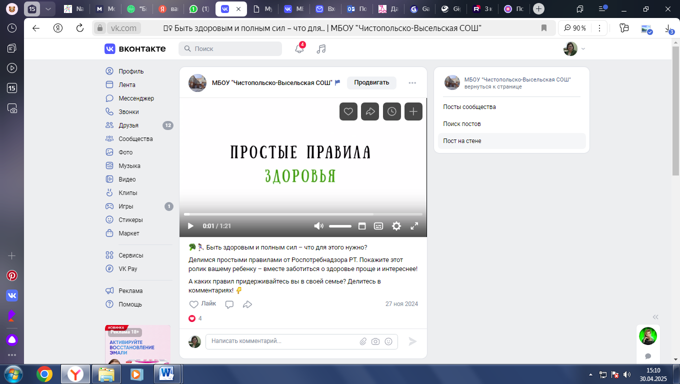
https://vk.com/wall-212007145_1940
